**DAILY ONLINE ACTIVITIES SUMMARY**

|  |  |  |  |  |  |  |  |  |
| --- | --- | --- | --- | --- | --- | --- | --- | --- |
| **Date:** | 16-06-2020 | | | | | **Name:** | K S Prajwal | |
| **Sem & Sec** | IV A sec | | | | | **USN:** | 4AL18CS032 | |
| **Online Test Summary** | | | | | | | | |
| **Subject** | | Complex analysis, probability and statistical methods | | | | | | |
| **Max. Marks** | | 30 | | **Score** | | | 28 | |
| **Certification Course Summary** | | | | | | | | |
| **Course** | DJANGO | | | | | | | |
| **Certificate Provider** | | | Udemy | | **Duration** | | | **3 hr** |
| **Coding Challenges** | | | | | | | | |
| **Problem Statement:**  1: program to binary reversal of a number. | | | | | | | | |
| **Status:** completed | | | | | | | | |
| **Uploaded the report in Github** | | | | | yes | | | |
| **If yes Repository name** | | | | | <https://github.com/alvas-education-foundation/KS_Prajwal> | | | |
| **Uploaded the report in slack** | | | | | yes | | | |

Online Test Details: (Attach the snapshot and briefly write the report for the same)

Certification Course Details: (Attach the snapshot and briefly write the report for the same)

Coding Challenges Details: (Attach the snapshot and briefly write the report for the same)

**Online Test Details:** The test for today was from module 1. The test was of objective type questions and there were 30 questions and the duration was 45 minutes. The questions were optimal and easy. The score that I got was 28/30.

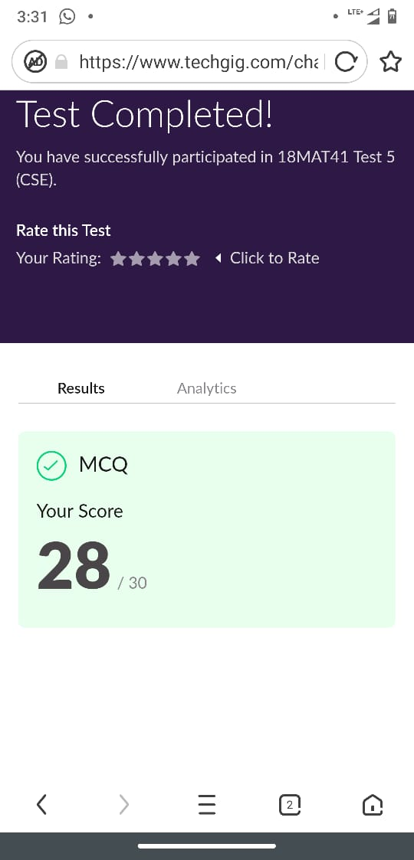

Snapshot of certification course: 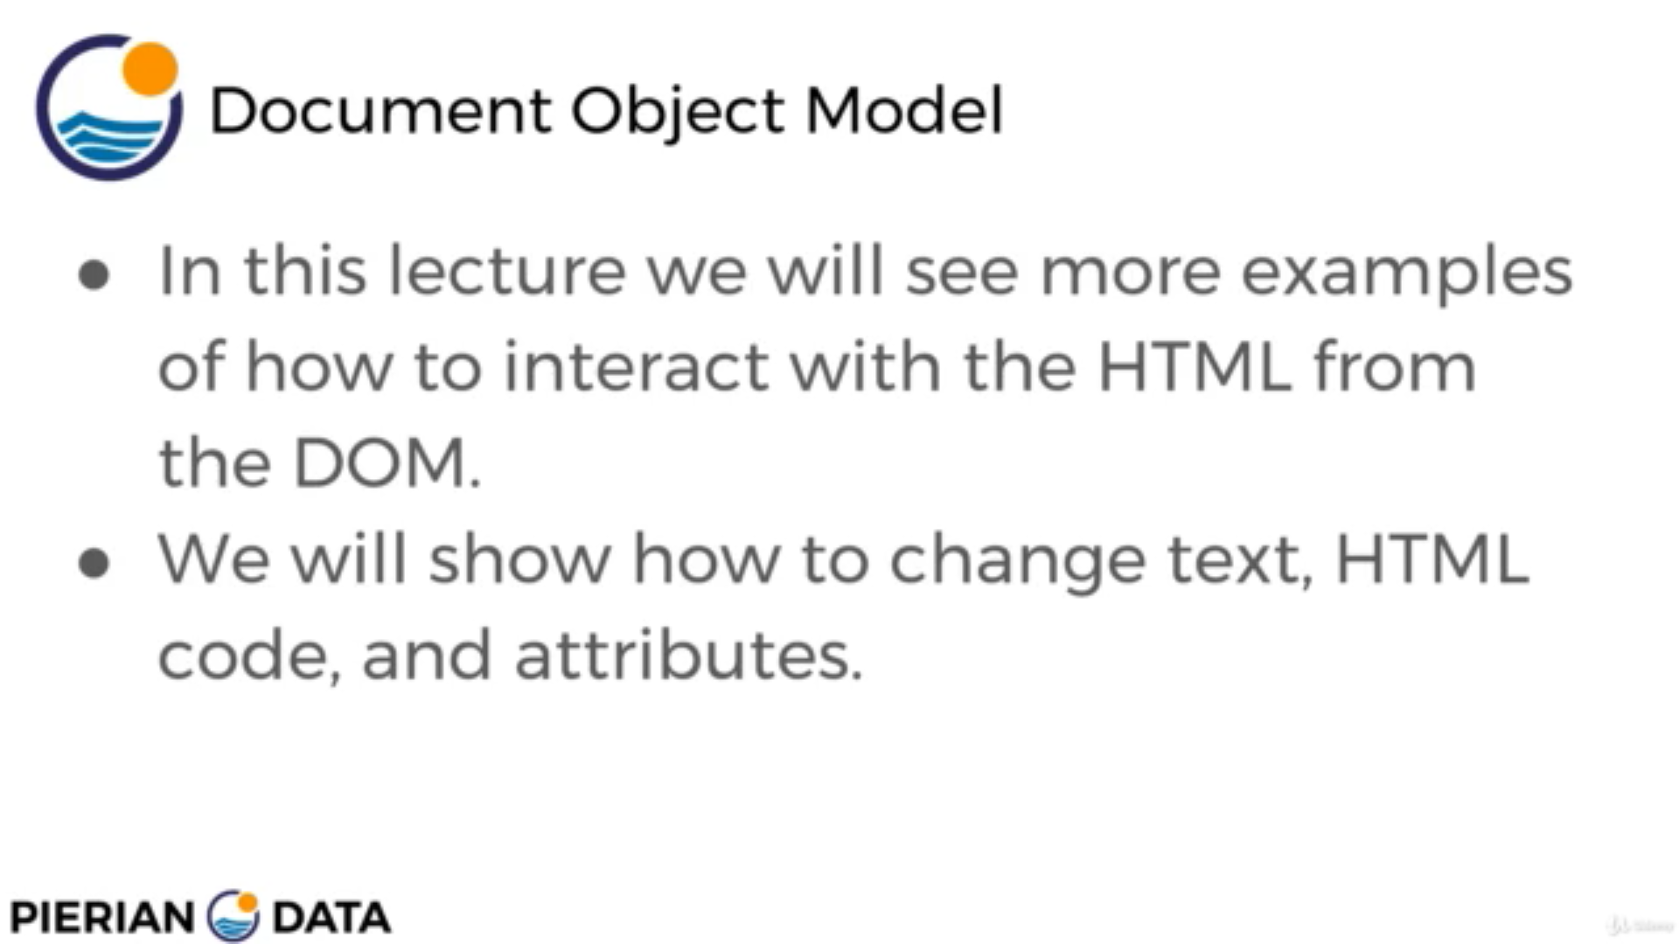

This section was about DOM ,Document Object Model

**Online coding:**

Problem 1: (using C language) program to binary reversal of a number.

